Name: Vishnu Mohan
Roll No: 51
Batch: MCA B
Date: 02-06-2022

NETWORKING & SYSTEM ADMINISTRATION LAB

Experiment No.: 23

Aim
Familiarization of basic network commands in linux
Procedure
tcpdump is a data-network packet analyzer computer program that runs under a command line interface. It allows the user to display TCP/IP and other packets being transmitted or received over a network to which the computer is attached. Distributed under the BSD license, tcpdump is free software.
1. sudo apt update && sudo install tcpdump
This commands in Linux allows you to install the tcpdump packet analyzer on your system
Syntax:- $ sudo apt update && sudo install tcpdump
Output:-
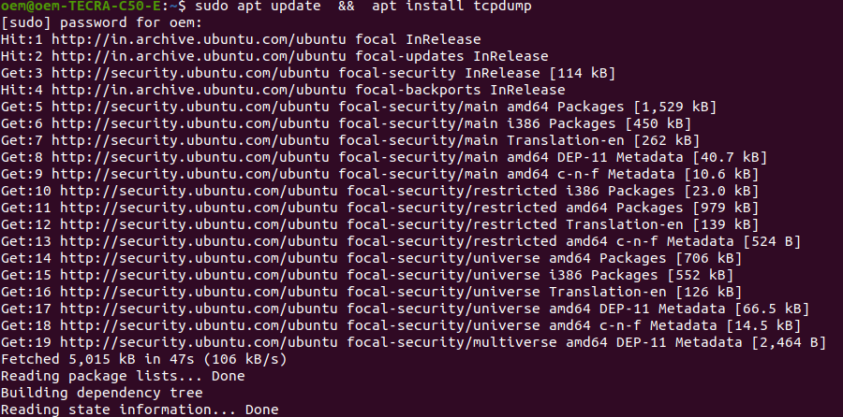

2. sudo tcpdump -D
To see the ist of network interfaces vailable on the system on which tcpdump can capture packets
Syntax:- $ sudo tcpdump -D
Output:-
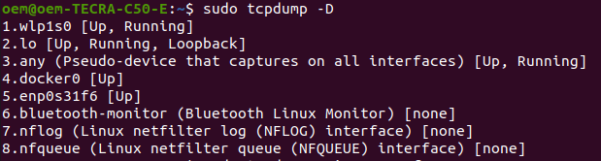

3. sudo tcpdump -i wlp1s0
To capture the packets following through a specific interface, we can use the -i flag with the interface name. Without the -i interface , tcpdump will pick up the first network interface it comes across.
Syntax:- $ sudo tcpdump -i wlp1s0
Output:-
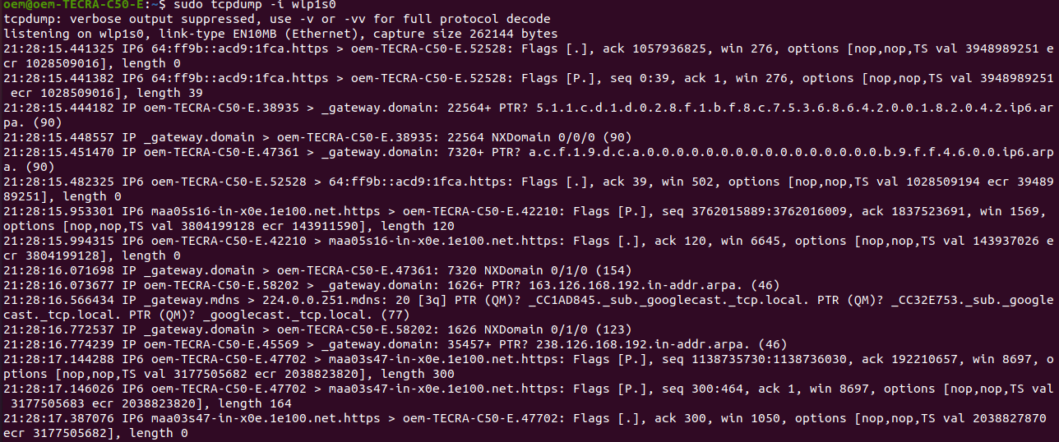
4. sudo tcpdump -c 4 wlp1s0 -i
This command is used to show the details of last 4 packets only
Syntax:- $ sudo tcpdump -c 4 enp3s0 -i

Output:-
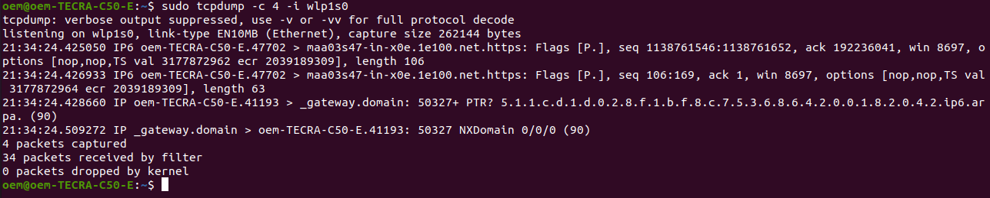
5. sudo tcpdump -XX -i wlp1s0
This command helps to see the information of the ip address in terms of ipv6 addressing
(in hexadecimal format)
Syntax:- $ sudo tcpdump -XX -i wlp1s0
Output:-
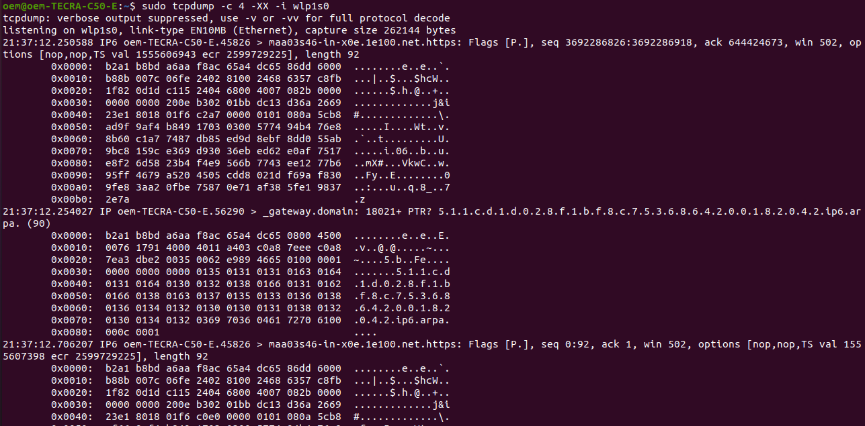

6. $ sudo tcpdump -i wlp1s0 -c5 port 80
To access information of packet from a specific port number
Syntax: $ sudo tcpdump -i <your_ethernet_interface> -c5 port <port_number>
Output:-
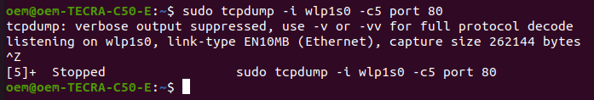
7. $ sudo tcpdump -i wlp1s0 -c 10 -w icmp.pcap
To store packet information limited by lines,words
Syntax:- $ sudo tcpdump -i <your_ethernet_interface> -c <lines> -w <filename>
Output:-
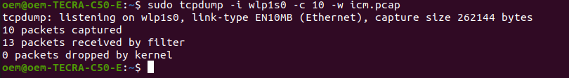
8. $ sudo tcpdump -r icmp.pcap
To read the content of a packet capture by using tcpdump
Syntax: $ sudo tcpdump -r <filename>
Output:-
